**Database Structure**

**User Table :**

* Username is this the colomn that user add the name
* Pwd is the colmn tha user add password
* Typeofuser is the colomn that user add Type like “admin or user”

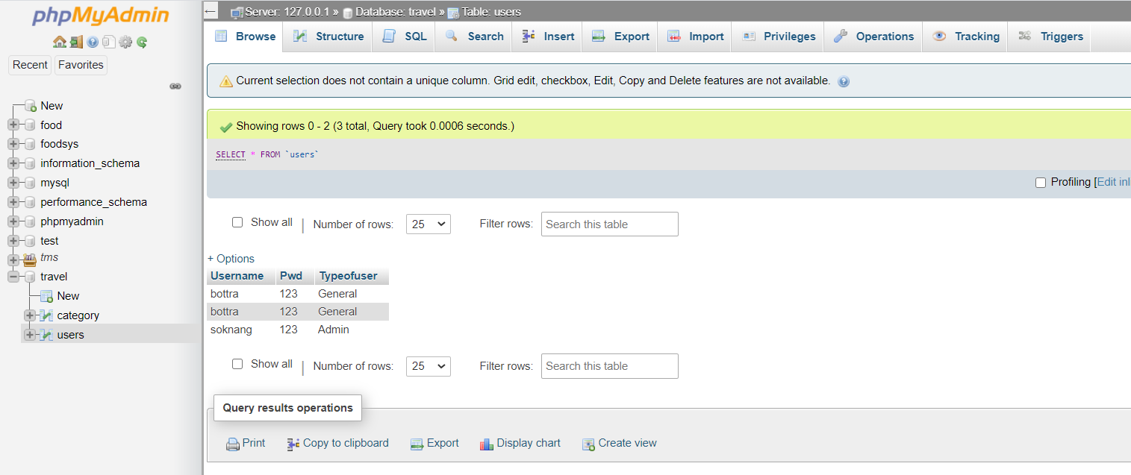

**Category Table :**

* Cat_id is the colomn that user add id of category
* Cat_name is the coloum that user add the name of category

